Technical Datasheet of RS485 over BLE5

Product Overview: -
WIN-GW-BLE5-RS485-T is an industrial-grade bai-directional RS-485 to BLE Transparent Bridge, designed to bridge legacy serial devices with modern IoT and BLE networks. Featuring a built-in Web UI, it allows easy configuration of RS-485 communication parameters. This compact and rugged device ensures reliable data transmission from serial devices to BLE platforms using the Transparent BLE protocol.

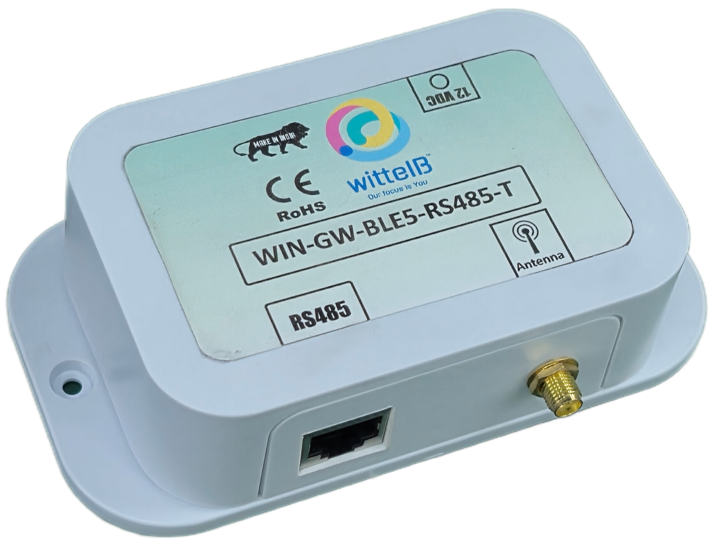

Key Features:
- RS485 Serial Interface
Supports long-distance serial communication (up to 1200 meters) with industrial devices.
- BLE Protocol Support
Publishes Transparent BLE↔RS485 gateway supporting custom commands and raw data exchange.
- BLE Wireless Communication Range (extendable)
Provide reliable BLE connectivity up to 20–30 meters in open line-of-sight (LOS) environments and 10–15 meters in non-line-of-sight (indoor/obstructed) conditions, depending on installation and interference levels.
- Web-Based Configuration
Intuitive Web UI for setting RS485 parameters as Baud/SID/Parity.
- Real-Time Data Publishing
Ensures low-latency communication to client dashboards.
- Compact & Industrial-Grade Design
Suitable for deployment in harsh environments.

Advantages:
- Transparent BLE0↔RS485 Communication
- Provides stable and high-speed data transfer for industrial environments.
- Low-Latency Data Publishing
- Real-time data delivery ensures accurate and timely monitoring.
- Allows multiple BLE devices to connect simultaneously for monitoring, control, and diagnostics.
- Compatible with custom mobile apps, BLE gateways, and embedded BLE hosts, for raw data transport.
- Supports BLE 5.0 connectivity.
- Offers a cost-effective way to modernize wired serial systems with wireless BLE connectivity.

Specifications:

- Dimensions : 70 mm L x 110 mm B x 50 mm H
- Power : 12 DC, typical power consumption – 5W
- Operating Temperature : 0 – 60° C (32 ~ 140°F)
- Storage Temperature : -20 - 70° C (-4 ~ 158°F)
- Storage Humidity : 5 ~ 95 % RH, non – Condensing


- Certifications :

Additional Features: -

- Communication Port isolated Input power reverse polarity safety
- ESD Safety IEC 61000-4-2, ± 30KV contact, ± 30KV air
- EFT IEC 61000-4-4, 50A (5/50ms) 750V isolation.
- CRC Error check.

WIFI Configuration Settings: -

- Connect a 24V AC/DC power supply to the module.
- Connect one or more RS485 slave devices/RS485 terminal to the module’s A & B terminals.
- Then Access the module WIFI and enter the IP: 192.168.4.1 to configure the RS485 setting.

(WIFI: WIN-GW-BLE-RS485, PASS: 12345678).
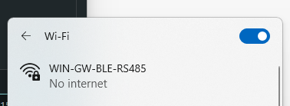
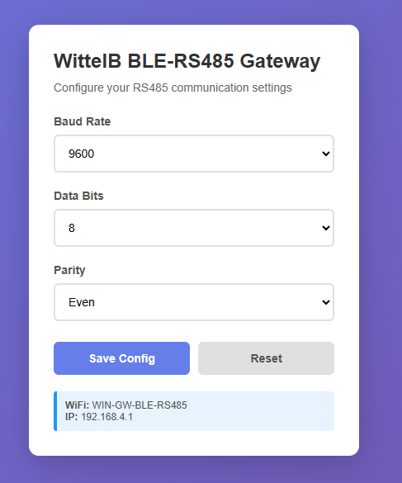

- Enter the Baud Rate, Data Bits, Parity, according to your communication settings.
- Here you can configure the serial communication parameters for the device you are setting up.

- BLE Client to RS485 Terminal:-

- Open BLE Client Apps (ex: NRF Connect) or customized BLE Applications.
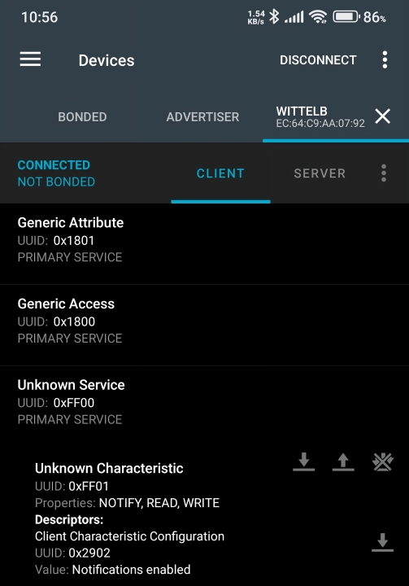
- Connect with BLE ID WittelB.

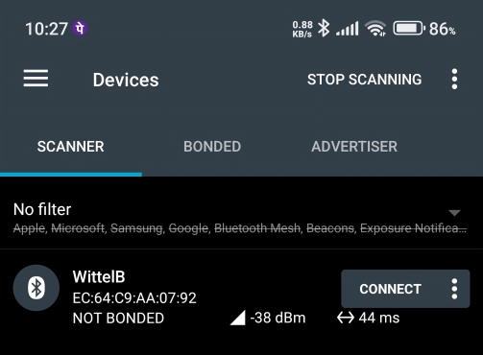

- After Connection enable the notification to read the packets.
- Also, you can write the commands for RS485 in hex.
- It supports 12 bytes and more.

- RS485 Terminal to BLE Client:-

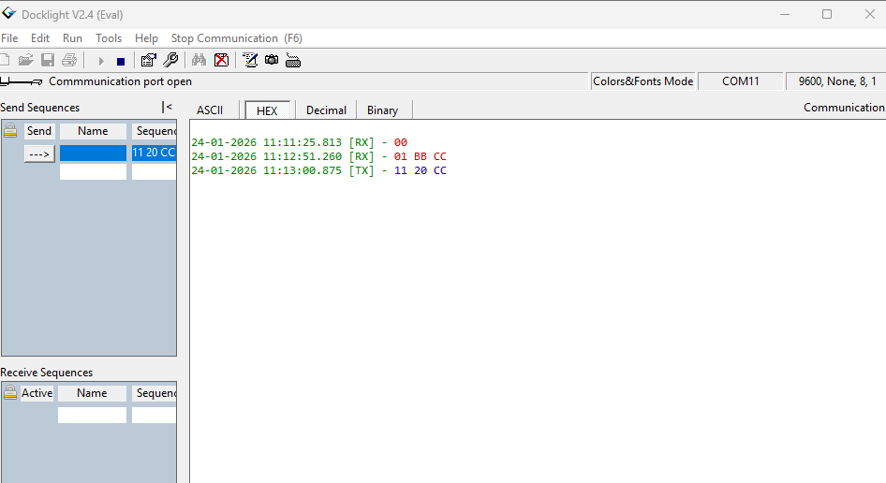
- Open RS485 Terminal (ex: Dock light) and connect with port and default RS485 address as baud: 9600, Data bit: 8, Parity: None.
- Then send hex commands from the RS485 Terminal, which will appears in BLE Client App as transparent.
- And also receive hex commands which is sent from the BLE Clients as transparent.
- It support 12 bytes and more.

- BLE Client to RS485 Slaves:-

- Open BLE Client Apps (ex: NRF Connect) or customized BLE Applications.
- Connect with BLE ID WittelB.
- Refer Image1&2 for BLE Connections.
- After Connection enable the notification to read the data packets of the slaves.
- Then write the command for RS485 slave in hex to read data packet.

Contact us: -
Augmatic Technologies Pvt. Ltd.,
Plot no 6, Shah Industrial Estate II,
Kotambi, Vadodara – 391510.
Vadodara – 391510.
Email – Sales@wittelb.com
Support E.: support@wittelb.raiseaticket.com / M.: 9403892805

